**Date Submitted: 12/3/18**

**Task 03: Using the collector and Sensor**

Youtube Link: <https://www.youtube.com/watch?v=CgqeeEBijNY&feature=youtu.be>

Collector ID:

D:\Oji\Documents\School\Fall2018\CPE 403\CC1350_Labs\Lab 5\collector.PNG

D:\Oji\Documents\School\Fall2018\CPE 403\CC1350_Labs\Lab 5\sensor.png

Sensor ID:

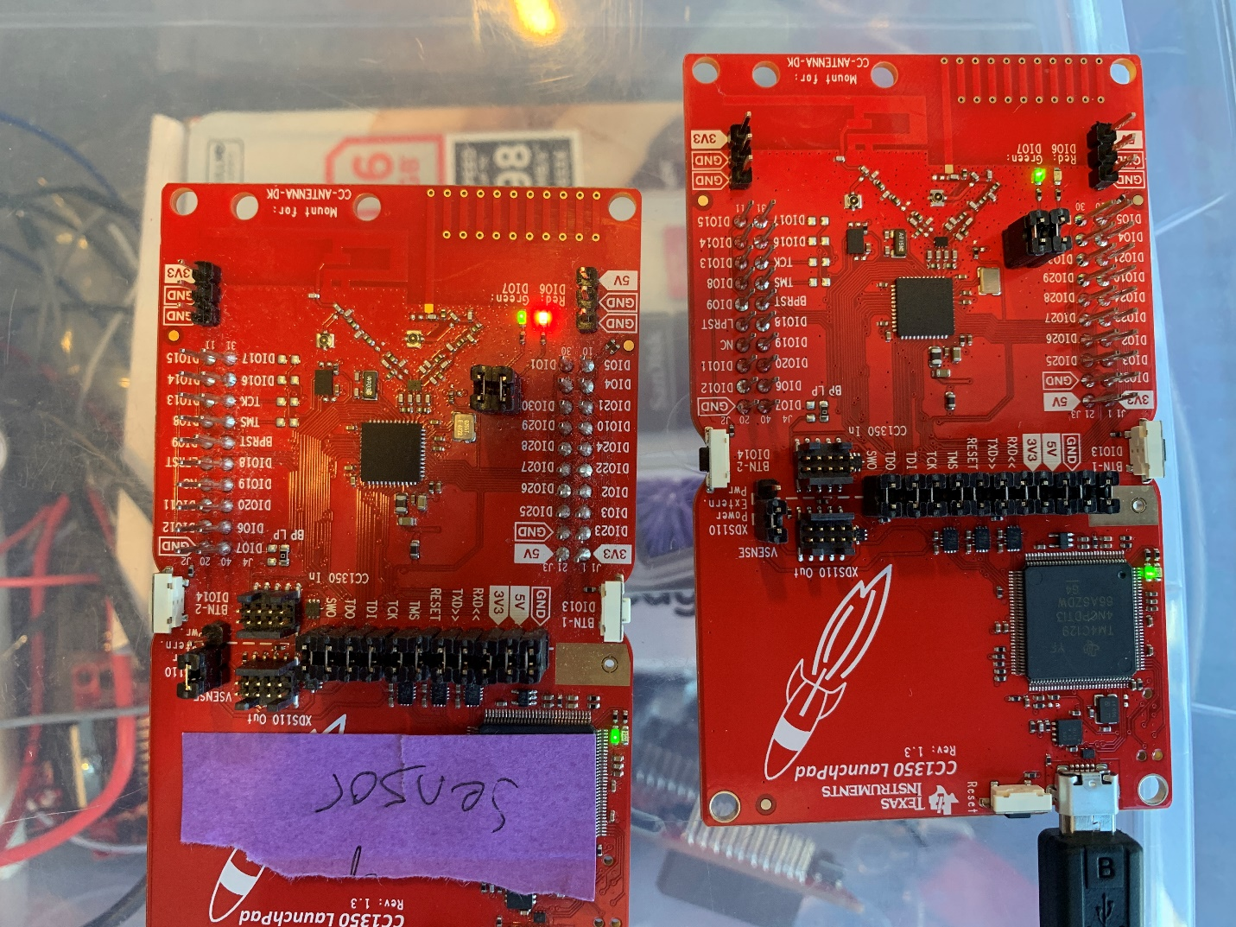

Output:

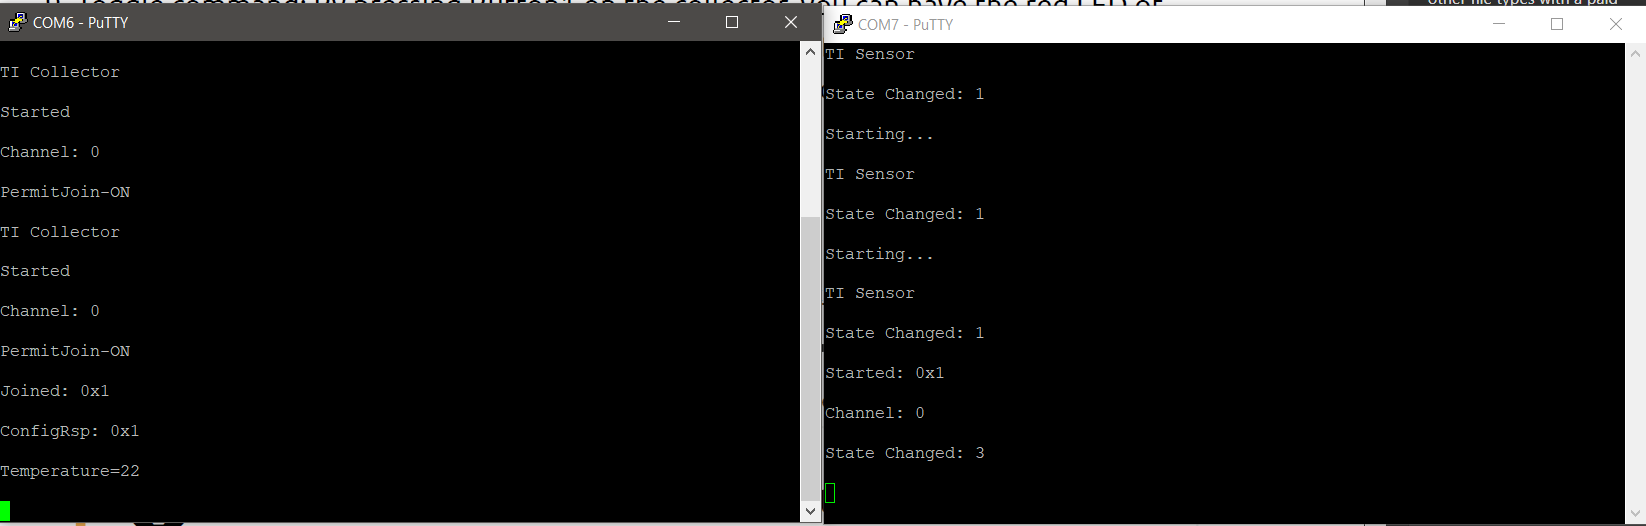

**------------------------------------------------------------------------------------**

**Task 04: Update the sensor’s reporting rate**



